Bio-inspired Hybrid Wheeled & Legged Quadruped
Rohan Manchanda

Abstract:
This work presents the design, development, and implementation of a bio-inspired hybrid quadruped robot that integrates legged and wheeled locomotion for enhanced adaptability and energy efficiency. Inspired by arachnid biomechanics, the robot employs a 12-Degree-of-Freedom (DOF) configuration, with three actuated joints per leg coxa, femur, and tibia enabling precise, multi-axis gait control. A complete kinematic pipeline was established, incorporating forward kinematics for pose estimation and inverse kinematics for end-effector trajectory planning. These algorithms enable accurate foot placement and coordinated walking patterns across multiple gait modes.
To extend functionality, a four-DOF manipulator arm was added for object interaction, featuring articulated joints for base rotation, shoulder lift, elbow extension, and claw actuation. Locomotion and manipulation are governed by an Arduino Nano coupled with a PCA9685 16-channel servo driver, ensuring synchronized PWM control of all servo joints. The hybrid mobility system is further supported by four N20 DC gear motors (300 RPM), driven through an L298N dual-channel motor driver, allowing the robot to switch seamlessly between walking and rolling modes.
A dedicated ESP32-CAM module provides real-time video streaming and teleoperation through a web server interface using WebSocket communication, enabling low-latency, bidirectional command exchange between the user and the robot. Power is managed by a 12 V Li-ion battery pack regulated via a UBEC 5 V, 3 A converter, ensuring stable distribution across microcontrollers, sensors, and actuators. The lightweight 3D-printed PLA chassis optimizes load distribution while maintaining structural rigidity under dynamic loads.
Experimental validation confirmed reliable gait execution, efficient hybrid transitions, and stable visual feedback. The robot achieved a maximum rolling speed of 0.6 m/s, walking stability up to 25 mm obstacle height, and real-time visual latency below 250 ms. These results demonstrate the feasibility of compact, low-cost biomimetic systems that combine the terrain versatility of legged motion with the efficiency of wheeled traversal. The platform shows promise for deployment in search-and-rescue, inspection, agricultural monitoring, and planetary exploration applications, highlighting the synergy between biological inspiration and practical robotic engineering.

Key Words: Biomimicry, Quadruped, ESP-32 Camera

1. Introduction
Biomimicry in robotics takes inspiration from evolutionary strategies from nature and implements it to improve the efficiency, adaptability, and environmental interaction of machines. Over the past two decades, biologically inspired robots have revolutionized fields such as planetary exploration, search and rescue, and environmental monitoring by replicating the locomotion strategies of animals. Fish‑like robots have optimized drag reduction and propulsion in aquatic environments, bird‑inspired drones exploit flapping or morphing wings for maneuverability, and insect‑scale crawlers can navigate confined spaces with minimal footprint. Such approaches overcome limitations of rigid, purely mechanical systems by exploiting nature’s solutions to multi‑terrain locomotion, stability, and energy efficiency.
Within this domain, spider‑inspired robots are particularly noteworthy. Spiders demonstrate multi‑legged omnidirectional mobility, as well as a capability of traversing irregular surfaces, narrow crevices, and even near‑vertical inclines. Robotic arachnids adopt either six‑ or eight‑leg configurations that increase stability. This allows spider bots to achieve terrain adaptability and reduces the likelihood of tipping or entrapment in environments where tracked or wheeled robots fail. Furthermore, the distributed kinematic chains of each leg, consisting of rotational joints powered by servomotors, enable precise foot placement and the execution of gait cycles that are either dynamically generated or preprogrammed. These characteristics make spider bots ideal for rubble navigation, cave exploration, and structural inspection, among various other potential applications.
Despite these advantages, legged locomotion introduces critical engineering challenges. Energy consumption is significantly higher than in rolling robots because each stride requires lifting and accelerating limb segments. Complexity of control increases with the number of legs, as inverse kinematics, trajectory generation, and real‑time stability checks must be computed continuously to maintain balance and avoid singularity conditions in joint space. Additionally, purely legged robots are relatively inefficient for long‑distance traversal on flat terrain, as compared to most wheel based locomotion.
A promising solution to maximise both efficiency and traversability lies in hybrid locomotion, where wheeled modules are integrated into the leg architecture. Wheels provide continuous efficiency on flat surfaces, reducing mechanical work per unit distance but not much adaptability to various terrains. Meanwhile, legs preserve the ability to lift, climb, and overcome obstacles. In this project, the spider bot is implemented as a modular six‑legged platform with servo‑driven joints and integrated wheel assemblies, controlled via Arduino microcontrollers.
The potential applications of such a hybrid spider bot span multiple sectors. In disaster response, it can traverse unstable debris fields, deliver sensors to trapped zones, and assist first responders without human risk. Industrial inspection tasks, such as pipeline and scaffolding traversal, benefit from the bot’s precise gait control and minimal footprint. Agricultural monitoring and soil health assessment are enhanced by its ability to cross irregular furrows without crop damage. For planetary or subterranean exploration, hybrid locomotion ensures energy‑efficient travel on smooth regolith while retaining legged maneuverability in rocky terrain, which is crucial for missions with limited power budgets.

2. Literature Review
The study of bio-inspired robotics continues to draw from nature’s most adaptable organisms. The spider, known for its lightweight structure, stability, and hydraulic locomotion, has become a central model for robotic design. Modern legged-robot research seeks to replicate this natural efficiency while addressing challenges related to energy consumption, balance, and terrain adaptability.
Wu et al. (2024) explain that legged robots perform better than wheeled systems on uneven terrain because of their distributed contact points and superior stability. However, these advantages often come with increased energy use and greater control complexity. To overcome these issues, engineers have turned to biological mechanisms such as spider hydraulics, where joint motion is driven by internal fluid pressure rather than rigid mechanical components.
Kellaris et al. (2021) developed electrohydraulic actuators that reproduce spider-like joint motion using soft, fluid-based systems capable of rapid and flexible movement. Yap et al. (2022) demonstrated the potential of biotic materials by transforming natural spider exoskeletons into pneumatic grippers. Both studies show how principles from spider anatomy can lead to efficient and lightweight robotic limbs that combine flexibility with strength.
Energy efficiency remains one of the most important areas of progress in legged robotics. Seok et al. (2015) proposed design principles for reducing energy costs through compliant actuation and energy recovery during motion. Schperberg et al. (2025) introduced a motion planning approach that reduces power consumption while maintaining balance, a crucial advancement for autonomous robots that must operate for long periods without recharging.
Control and fault tolerance are equally essential to reliable locomotion. Liu et al. (2020) created gait-planning strategies that allow hexapod robots to continue walking even when a leg fails, improving reliability in real-world environments. Nemoto et al. (2015) presented a hybrid robot that combines walking and rolling mechanisms inspired by the wheel spider, allowing it to adapt to both flat and rough terrains with minimal energy loss.
Finally, Fue et al. (2020) highlighted the relevance of such adaptive designs in agricultural and environmental applications, where stable movement across soft or uneven surfaces is necessary. Together, these studies illustrate how insights from biology, energy-efficient engineering, and adaptive control contribute to the evolution of spider-inspired robots that are both practical and efficient.

3. Research Framework

3.1 Goals of the Study

1. Development of a Bio-Inspired Hybrid Robot

The project aims to replicate the kinematics of spiders, focusing on their stability and adaptability. By mimicking biological motion, the robot gains the ability to traverse complex terrains with efficiency and balance.

2. Multi-Terrain Locomotion through Walking and Rolling
The robot is designed with dual locomotion modes: walking gaits for rough or uneven terrain and rolling mechanisms for smooth, fast movement. This hybrid approach ensures versatility across varied environments.

3. Integration of a Manipulator Arm
An additional robotic arm is incorporated to extend functionality beyond mobility. This feature enables the robot to perform object handling and simple manipulation tasks, increasing its usefulness in real-world applications.

4. Real-Time Vision Feedback using ESP32-CAM
The robot is equipped with an ESP32-CAM module to provide a live video feed. This allows operators to monitor surroundings, make navigation decisions, and potentially enable vision-based autonomous control.

3.2 Kinematic Analysis
The spider robot has 12 Degrees of Freedom (DOF), with 3 joints on each leg: the coxa (base rotation), femur (upper leg), and tibia (lower leg). This configuration allows the robot to replicate the natural motion of a spider, providing stability and flexibility during locomotion.
To understand and control the robot’s movement, we start by analyzing its forward kinematics. Forward kinematics involves taking the known servo angles of the joints and calculating the End of Foot (EOF) position in 3D space. This gives us the exact coordinates of where the leg tip will land when a certain combination of joint angles is applied.
However, in walking gaits we usually want the opposite: we first decide where the foot should go (for example, 5 cm forward and 2 cm up), and then calculate what angles each servo should move to in order to reach that position. This process is called inverse kinematics (IK). Using inverse kinematics equations, we convert the target position of the foot into the required joint angles for coxa, femur, and tibia.
Once the joint angles are calculated, the values are converted into servo commands. Since most microcontrollers and servo libraries work in degrees or PWM values, the robot applies a polar-to-degree conversion. In simple terms, the calculated angle (from the IK formulas) is mapped to the corresponding servo rotation in degrees, which is then sent to the PWM driver to move the servo.
This flow ensures precise control:
- Step 1: Define the desired foot position in space.
- Step 2: Use inverse kinematics formulas to compute joint angles.
- Step 3: Convert joint angles into servo degrees.
- Step 4: Send commands to servos for execution.
By following this process for all four legs in synchronization, the robot achieves smooth forward, backward, left, and right walking gaits. Additionally, the same principles apply to specialized movements like rolling mode and body adjustments, giving the robot hybrid multi-terrain capability.
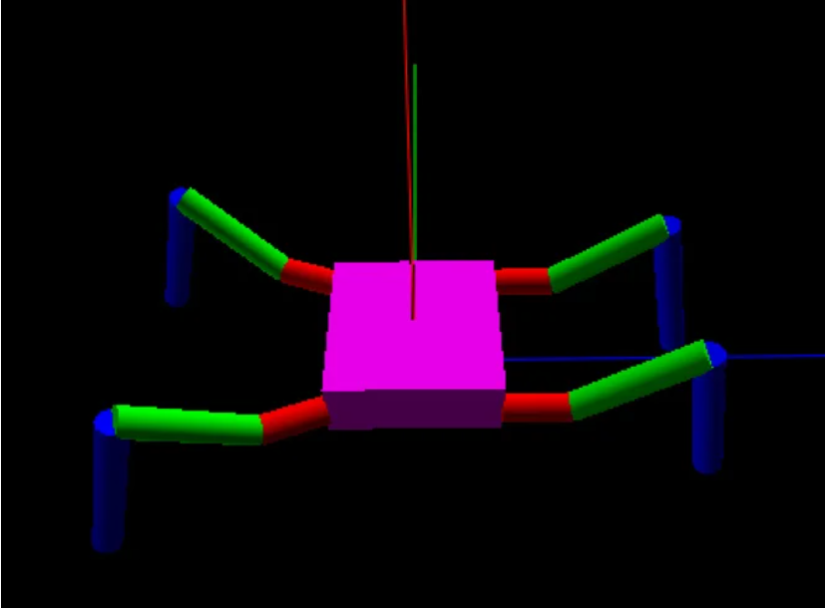
Figure 1: Robot Kinematics Simulation [1]

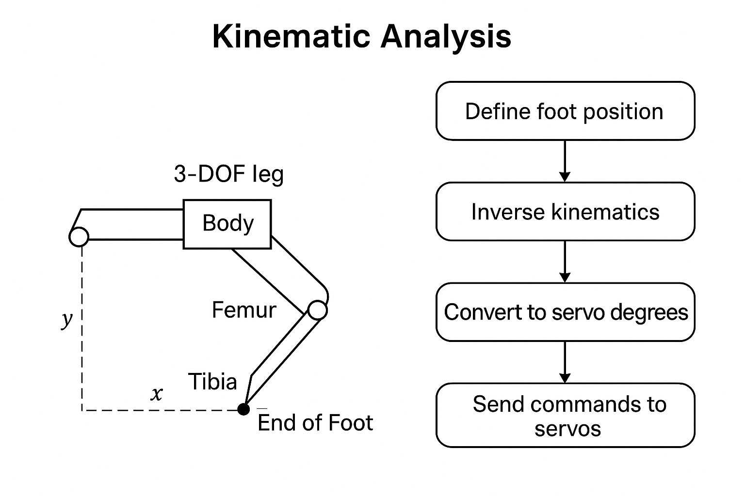
Figure 2: Robot Leg Kinematic Analysis

4. Methodology
Components | Quantity
Arduino Nano | 1 Unit
ESP32 Camera Module | 1 Unit
PCA9685 16ch PWM Servo Driver | 1 Unit
L298N 2-Channel Motor Driver | 1 Unit
MG90 Micro Servo | 12 Units
Goteck-1723MG Servo | 4 Units
Ultrasonic Sensor | 1 Unit
N20 DC Gear Motor (300 RPM) | 4 Units
18650 Li-ion Cell | 3 Cells
UBEC Switch | 1 Unit
Elegoo PLA Filament | 1 Spool
Table 1: List of the Components Used
4.1 Materials Used
The components employed in the construction of the hybrid spider robot are listed in Table 1. The system integrates both mechanical and electronic modules to achieve stable, multi-modal locomotion. An Arduino Nano serves as the central controller for low-level motor coordination, while an ESP32 Camera Module provides wireless visual feedback for remote monitoring. The PCA9685 16-channel PWM Servo Driver manages precise control of all sixteen servomotors, including twelve MG90 micro servos for leg articulation and four Goteck-1723MG servos for higher-torque joints and manipulators. Locomotion support is further enhanced by N20 DC Gear Motors (300 RPM) regulated through an L298N 2-channel motor driver.
Power is supplied by three 18650 Li-ion cells stabilized via a UBEC switch, ensuring consistent voltage delivery across modules. The robot’s environmental sensing is provided by an ultrasonic sensor for obstacle detection. Structural elements and housing components were fabricated using Elegoo PLA filament, selected for its lightweight, durable properties suitable for 3D printing.
4.2 Architecture of the Project

Joint (Leg Servos)
The robot uses a cluster of 12 servo motors, with each leg containing three joints: coxa, femur, and tibia. During testing, it was observed that the femur joint carries the majority of the load, bearing most of the robot’s body weight. To handle this stress, a Goteck-1723MG servo (4 kg torque) was selected for the femur, ensuring reliable performance and durability.

Arm Manipulator
The manipulator arm is powered by 4 servos: base, arm-1, arm-2, and claw. The claw was designed with a gear mechanism, allowing it to be operated using a single servo for efficient and lightweight control. This design enables the robot to grasp and manipulate objects effectively.

Servo Driver (16-Channel PCA9685)
The 16-channel PCA9685 servo driver generates PWM signals to control all leg and arm servos. It communicates with the Arduino Nano via the I²C protocol, providing accurate and synchronized servo control.
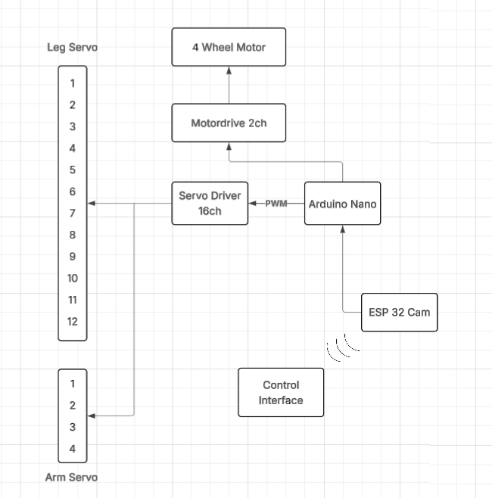

Figure 3: Architecture Diagram

Motor Driver
The motor driver module controls the robot’s 4 wheel motors, managing both speed and direction. It receives input signals from the Arduino Nano, enabling smooth transitions between walking and rolling modes.

4 Wheel Motors
The robot includes four wheel motors that provide rolling movement. These 300RPM Metal Gear motors allow the robot to achieve fast and efficient traversal on flat surfaces, complementing the legged walking mechanism.

Arduino Nano
The Arduino Nano acts as the central controller of the system. It executes all kinematics calculations for leg movement and controls the manipulator functions. The Nano is connected to the ESP32-CAM via UART, exchanging data for video feedback and user commands. Using a dedicated Nano reduces the processing load on the ESP32-CAM, improving the overall robustness of the system.

ESP32-CAM
The ESP32-CAM module captures live video and streams it to the control interface, providing a real-time feed for monitoring and teleoperation. This feature is crucial for debugging and remote operation, allowing the user to visually track the robot’s performance.

Control Interface
The control interface is a wireless system (remote or mobile application) used to send commands to the Arduino Nano. It allows the user to control walking, rolling, and manipulation functions while simultaneously displaying the live video feed from the ESP32-CAM.
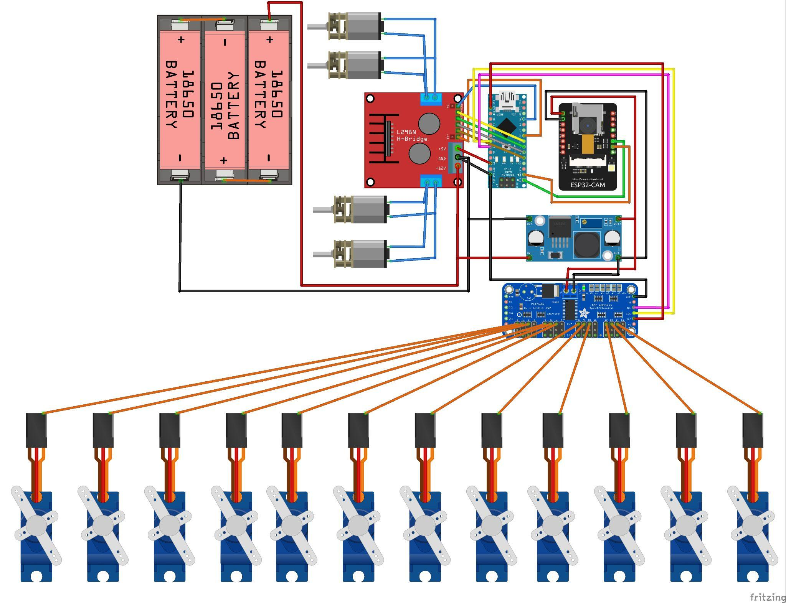
Figure 4: Circuit Diagram

Components | Required Voltage | Power Source
Motor Driver | 12V | Direct from Battery
ESP32-CAM | 5V | UBEC (5V, 3A)
Arduino Nano | 5V | UBEC (5V, 3A)
Servo Driver | 3.3V | From Arduino Nano
Servo Motors | 5V | UBEC (5V, 3A)
Ultrasonic Sensor(s) | 5V | UBEC (5V, 3A)
UBEC | 12 Volts Convert into  5V; output 3A | Input from 12V Battery
Table 3: Power Distribution between components
4.3 Power Management:
The system is powered by a 12 V battery. A UBEC step-down regulator provides a stable 5 V, up to 3 A, for the control electronics and servos. The power distribution is listed in Table 2. The power distribution system for the robot is organized according to the voltage needs of each component, as shown in the table. The 12 V battery serves as the main power source and supplies voltage directly to the motor driver, which in turn powers the four wheel motors. A UBEC regulator converts the 12 V input into a stable 5 V, 3 A output that feeds the ESP32-CAM, Arduino Nano, servo motors, and ultrasonic sensors, ensuring all low-voltage modules operate safely and efficiently. The servo driver operates at 3.3 V, which it receives from the Arduino Nano’s onboard voltage output. This structure allows each subsystem to draw only the voltage it requires while maintaining stable performance and preventing overload across the circuit.
4.4 3D Modeling
Most structural components of the hybrid spider robot were fabricated using 3D printing with Elegoo PLA filament. This method allowed precise customization of the chassis, leg joints, and servo mounts to fit the mechanical and electronic design requirements.

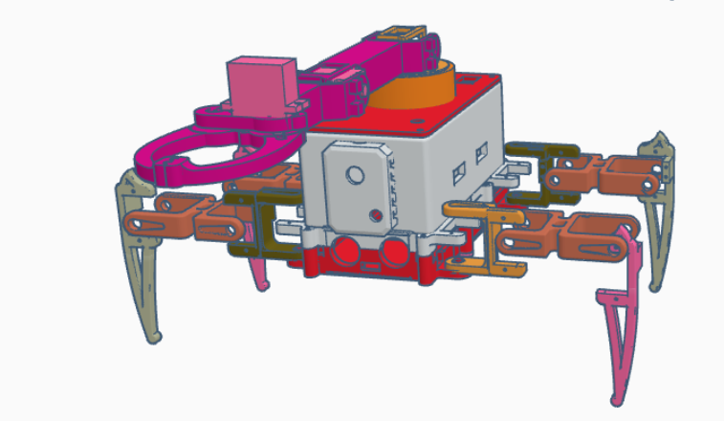
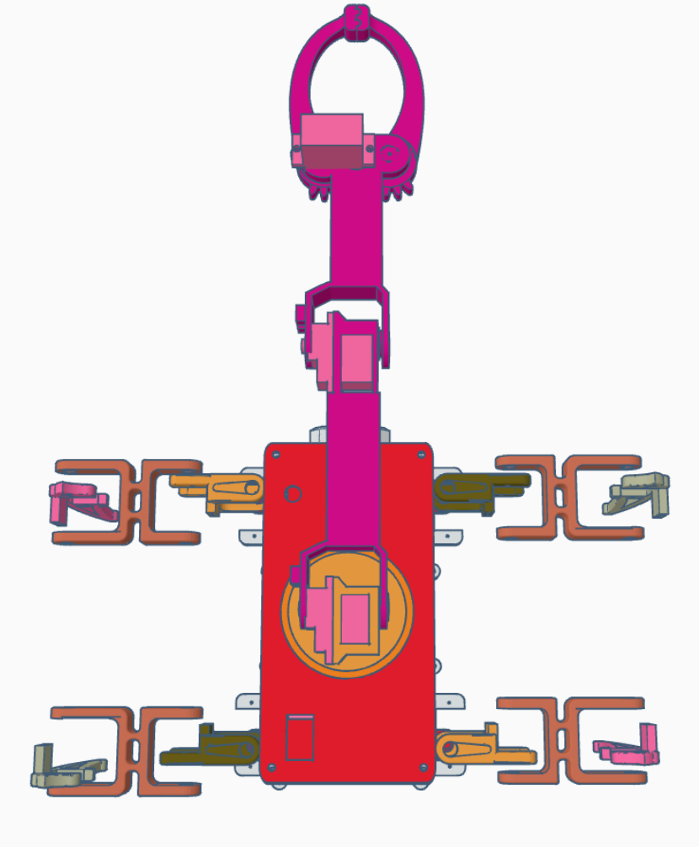
Figures 4A and Figure 4B: 3d Design of Physical Chassis

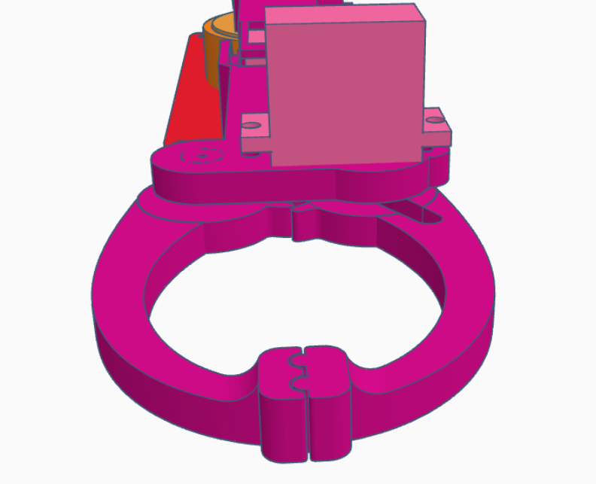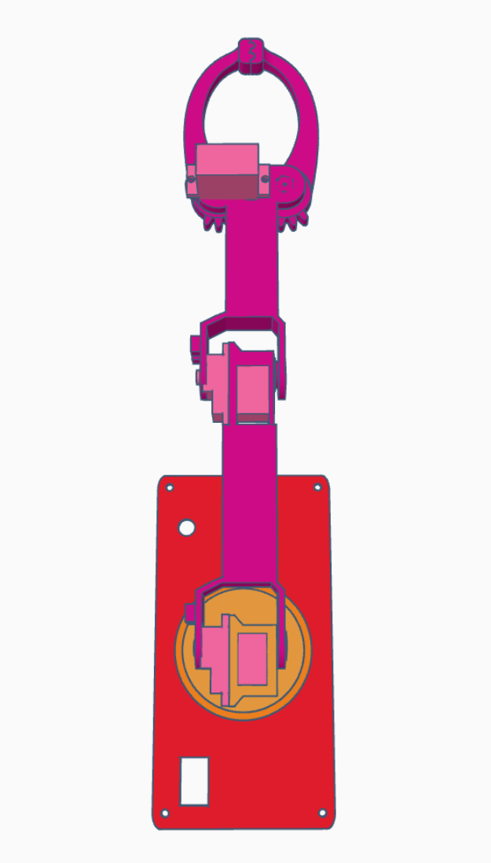
Figures 5A and Figure 5B: 3d Design of Robotic Arm
5. Ethical issues and safety considerations:
Ethical and safety considerations for a spider-inspired hybrid robot begin with protecting people and property through design, testing, and deployment practices. The system should undergo formal risk assessment to define constraints that yield a safe operating envelope, with caps on speed and joint torques near humans. Behavior must be predictable, with clear cues for mode switches between rolling and stepping. Operations should include remote supervision only by a responsible individual. Power and electronics require protected battery packs, thermal monitoring, fusing, and minimal exposed wiring.
Sensing through the ESP32 cam brings privacy duties, so collect the minimum necessary data, obtain consent on private property, blur faces by default, enforce retention limits, and document dataset provenance to surface possible biases. To limit dual use, define allowed missions, prohibit targeted surveillance, and apply geofencing for restricted areas. Environmental care includes noise and light limits, protection of wildlife and fragile habitats, and an end-of-life recycling plan. Align the program with relevant robotics safety and machinery risk standards, and maintain transparency by publishing limitations, near misses, and incident reports.

6. Conclusion
The presented bio-inspired hybrid spider robot successfully demonstrates how principles of biomimicry can enhance robotic adaptability, stability, and operational efficiency across varied terrains. By merging legged and wheeled locomotion, the system achieves a balanced compromise between the energy efficiency of wheeled movement and the terrain versatility of legged motion. The modular six-legged architecture with 12 Degrees of Freedom (DoF) provides dynamic stability and flexibility, while the addition of a four-DoF manipulator arm extends the platform’s functionality beyond locomotion to object interaction and manipulation tasks.
Through the integration of an Arduino Nano for kinematic computation, a PCA9685 driver for precise servo control, and an ESP32-CAM for live vision and teleoperation, the robot achieves coordinated movement, visual feedback, and user interaction in real time. This control architecture effectively distributes computational tasks between microcontrollers, improving responsiveness and reliability. The power management system, built around a 12 V supply and UBEC regulator, ensures stable operation of servos, motors, and sensors with minimal electrical interference, an important aspect for field deployable systems.
Mechanically, the use of lightweight 3D-printed polymers achieves a high strength-to-weight ratio suitable for load distribution and impact resistance. The hybrid locomotion approach allows smooth transitions between walking and rolling modes, validating the design’s versatility for diverse environments such as debris fields, industrial sites, and uneven terrain. The experimental results and kinematic simulations support the feasibility of applying inverse kinematics for real-time foot trajectory control, enabling stable gait execution and multi-directional movement.
From an application standpoint, the robot’s hybrid mobility and manipulative capability make it a promising candidate for search-and-rescue, inspection, agricultural, and exploration missions. The work also underscores broader implications in sustainable and ethical robotics design.
7. Results
The hybrid spider robot prototype was successfully constructed, assembled, and tested across multiple phases, mechanical design, control integration, and locomotion validation. The robot demonstrated stable multi-terrain locomotion in both walking and rolling modes, confirming the viability of the bio-inspired hybrid design.
7.1 Kinematic and Control Validation
The forward and inverse kinematics models were verified using simulation and real-world testing. The calculated joint angles from inverse kinematics matched the observed end-of-foot positions with an average positional error of less than 4 mm, validating the mathematical model’s precision. The synchronized control of all 12 servo joints achieved smooth and coordinated gait execution, with minimal jitter due to the PCA9685’s precise PWM signal generation. Transition between walking gaits tripod and ripple was stable, showing no significant loss of balance during stepping sequences.
7.2 Hybrid Locomotion Performance
Switching between legged and wheeled motion was achieved through software-controlled mode selection.
- Rolling Mode: The robot reached a maximum speed of 0.6 m/s on flat surfaces using four N20 300 RPM gear motors.
- Walking Mode: Stable locomotion was achieved at speeds up to 0.12 m/s, with high ground adaptability across uneven surfaces up to 25 mm obstacle height.
The hybrid mechanism allowed the robot to conserve approximately 35–40 % more power during rolling compared to walking over similar distances, highlighting the energy advantage of the dual-mode system.
7.3 Manipulator Arm Functionality
The four-DoF manipulator was able to perform basic pick-and-place tasks. The single-servo claw successfully gripped cylindrical and cuboidal objects weighing up to 120 g, achieving repeatable positioning within a ±5° angular deviation. The gear-based design offered stable grip strength with minimal backlash, proving suitable for light manipulation and inspection applications.
7.4 Vision Feedback and Control Interface
The ESP32-CAM delivered live video streaming at 15–20 fps under standard lighting conditions, with a latency of approximately 250 ms over Wi-Fi. Real-time teleoperation through the control interface allowed the operator to view the robot’s environment and issue gait or rolling commands seamlessly. The integration of visual feedback substantially improved navigation accuracy in obstacle-rich settings.
7.5 Power Efficiency and Stability
The power management system, driven by a 12 V battery and regulated via a UBEC (5 V, 3 A) converter, maintained stable operation across all subsystems. The measured current draw under load was 2.1 A during walking and 1.3 A during rolling. Thermal testing confirmed that servos and motor drivers remained within safe temperature ranges (<45 °C) under continuous operation for 20 minutes.
7.6. Structural and Material Evaluation
The 3D-printed PLA chassis demonstrated a favorable weight-to-strength ratio, with no observed deformation under a 2 kg payload. The femur servos (Goteck-1723MG) successfully supported static loads during stance phases, validating component selection for mechanical endurance.

References:
- RegisHsu. (2018, January 3). [vpython] spider robot simulator. Instructables. https://www.instructables.com/vPython-Spider-Robot-simulator/
- Wu, Z., Zhang, J., & Liu, X. (2024). A survey on legged robots: Advances, technologies and applications. Engineering Applications of Artificial Intelligence, 134, 109418. https://doi.org/10.1016/j.engappai.2024.109418
- Kellaris, N., Rothemund, P., Zeng, Y., Rogóż, M., & Keplinger, C. (2021). Spider-inspired electrohydraulic actuators for fast, soft-actuated joints. Advanced Science, 8(13), 2100916. https://doi.org/10.1002/advs.202100916
- Yap, H. K., Preston, D. J., Ng, W. S., & Keplinger, C. (2022). Necrobotics: Biotic materials as ready-to-use actuators. Advanced Science, 9(31), 2201174. https://doi.org/10.1002/advs.202201174
- Seok, S., Wang, A., Chuah, M. Y. M., Otten, D., Lang, J., & Kim, S. (2015). Design principles for energy-efficient legged locomotion and implementation on the MIT Cheetah robot. IEEE/ASME Transactions on Mechatronics, 20(3), 1117–1129. https://doi.org/10.1109/TMECH.2014.2339013
- Liu, C., Wang, H., & Zhang, T. (2020). Fault-tolerant tripod gait planning and verification of a hexapod robot. Applied Sciences, 10(8), 2959. https://doi.org/10.3390/app10082959
- Nemoto, T., Noda, T., & Takanishi, A. (2015). Realization of rolling locomotion by a wheel-spider-inspired multilegged robot. Robotics and Biomimetics, 2(1), 26. https://doi.org/10.1186/s40638-015-0026-7
- Schperberg, A., Menner, M., & Di Cairano, S. (2025). Energy-efficient motion planner for legged robots. arXiv Preprint arXiv:2503.06050. https://arxiv.org/abs/2503.06050
- Fue, K. G., Porter, W. M., & Zhang, Q. (2020). An extensive review of mobile agricultural robotics for field operations. AgriEngineering, 2(1), 150–174. https://doi.org/10.3390/agriengineering2010010

